**1.oracle plsql records and collection’s introduction to oracle collections**

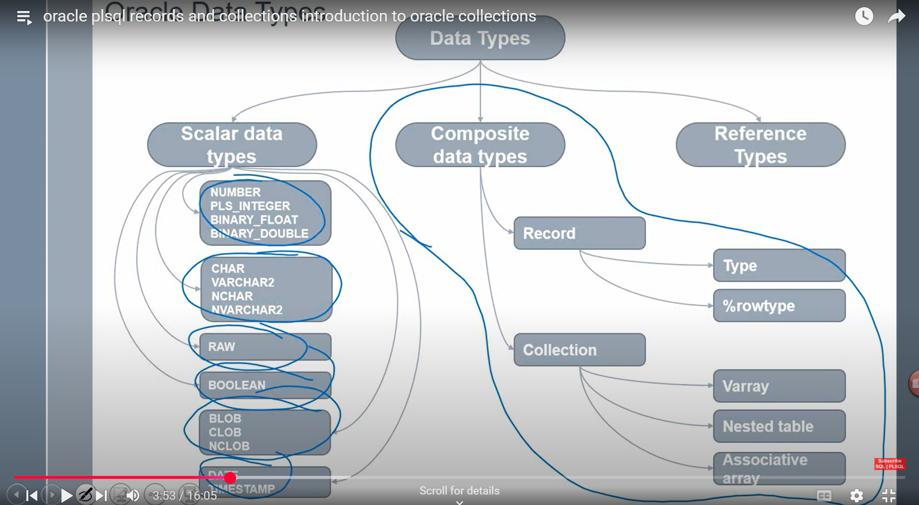

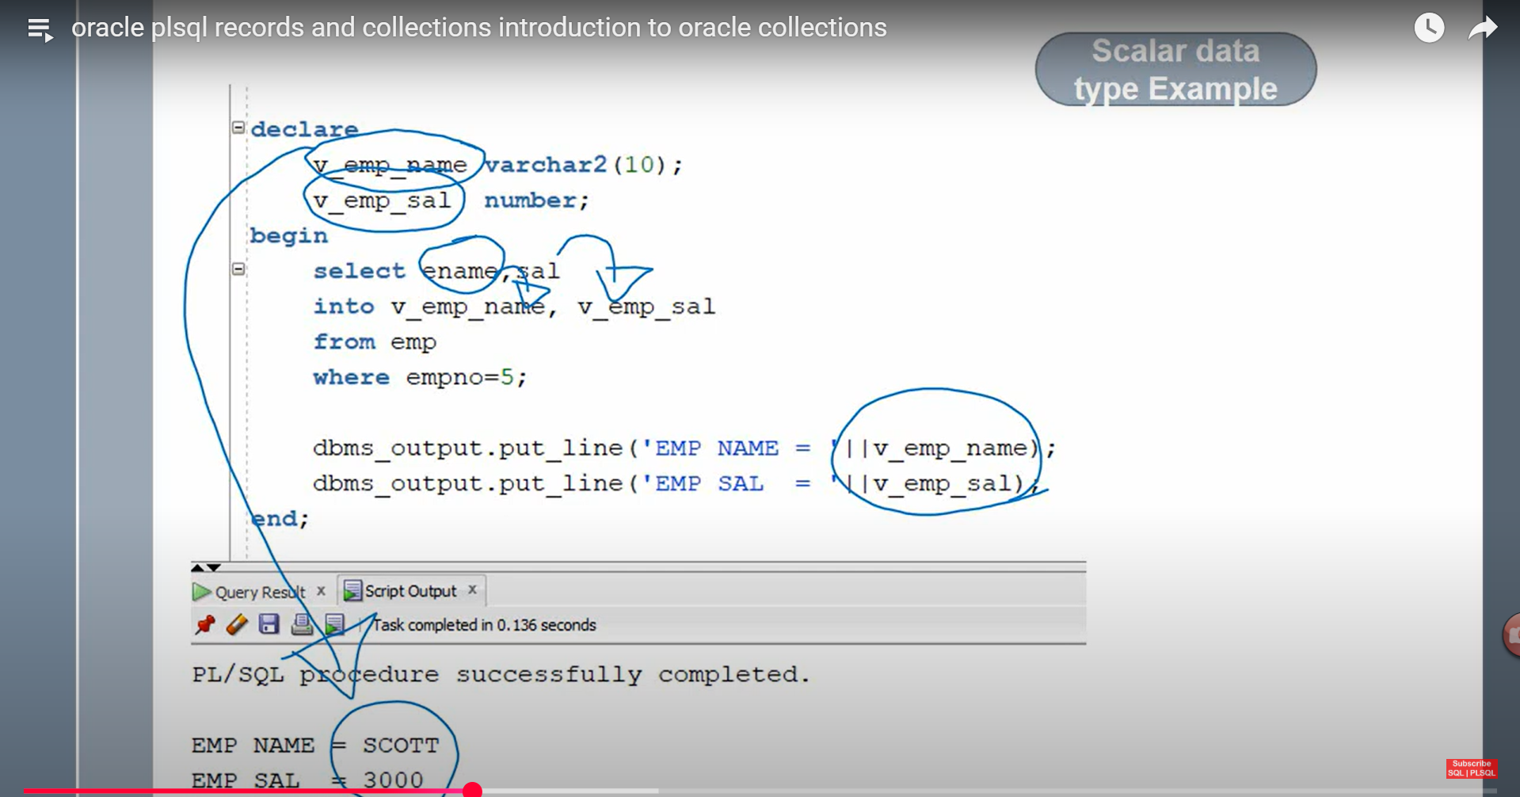

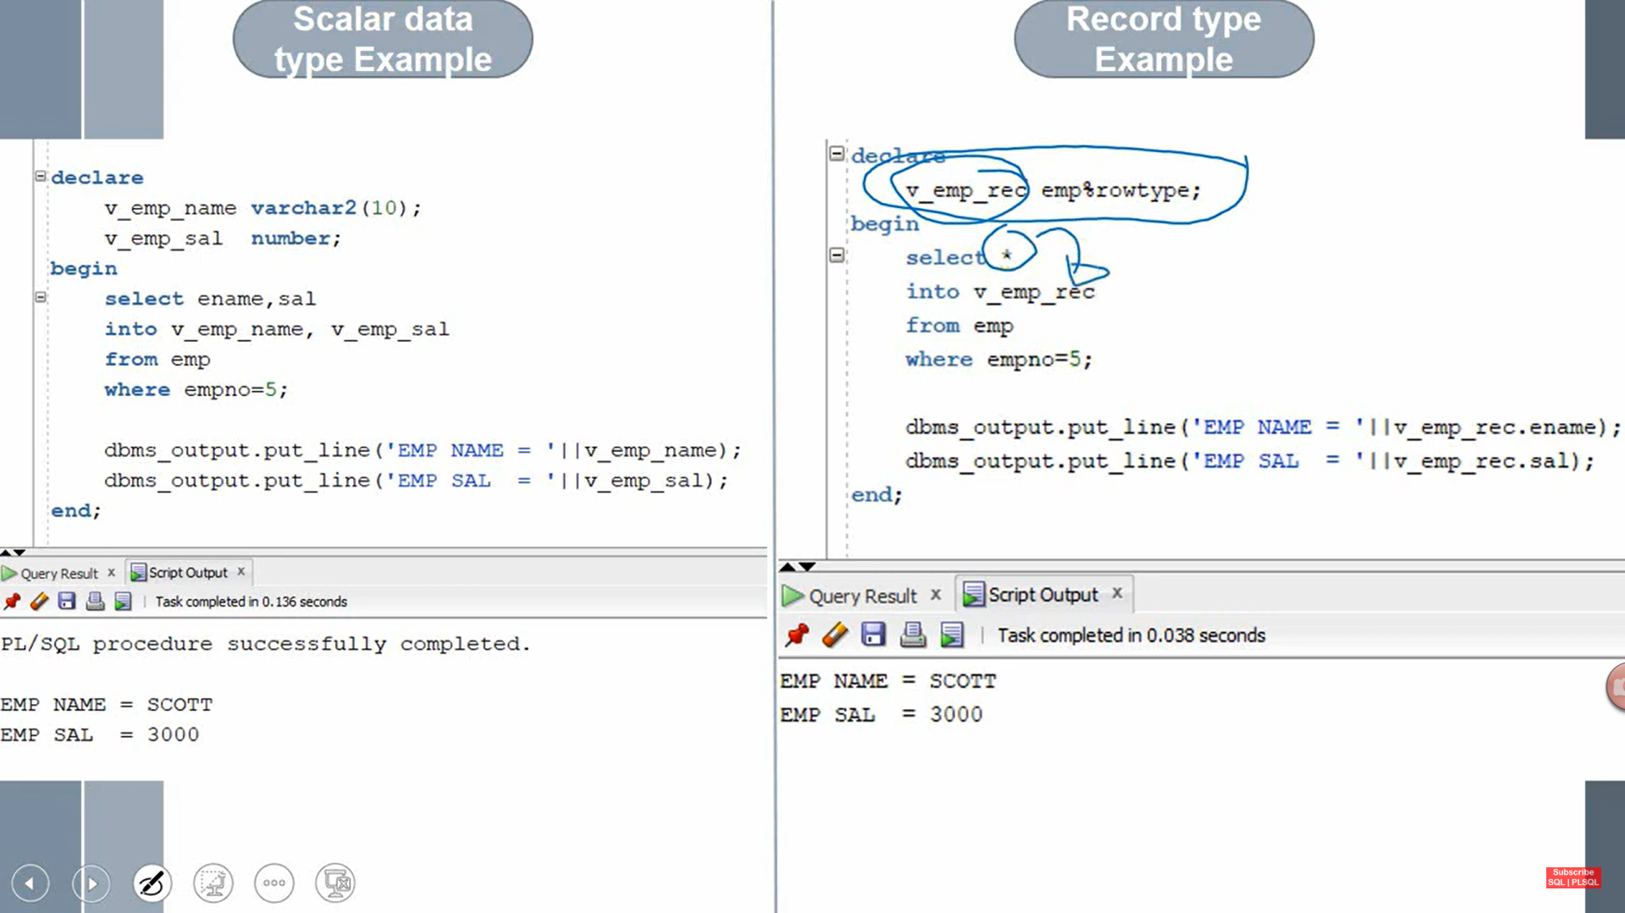

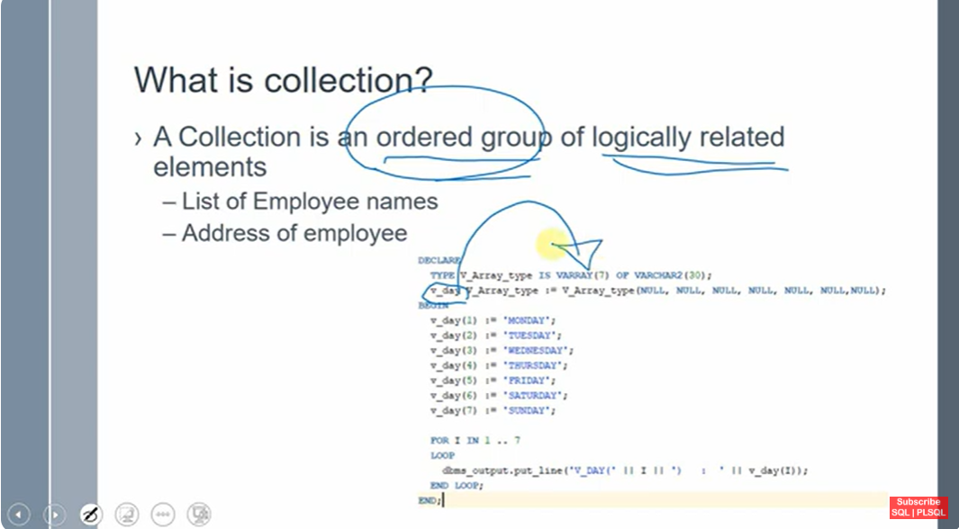

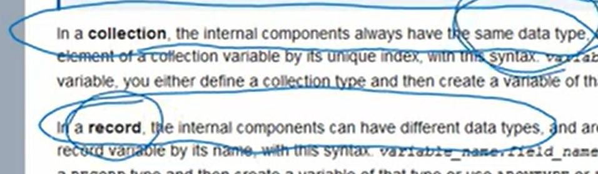

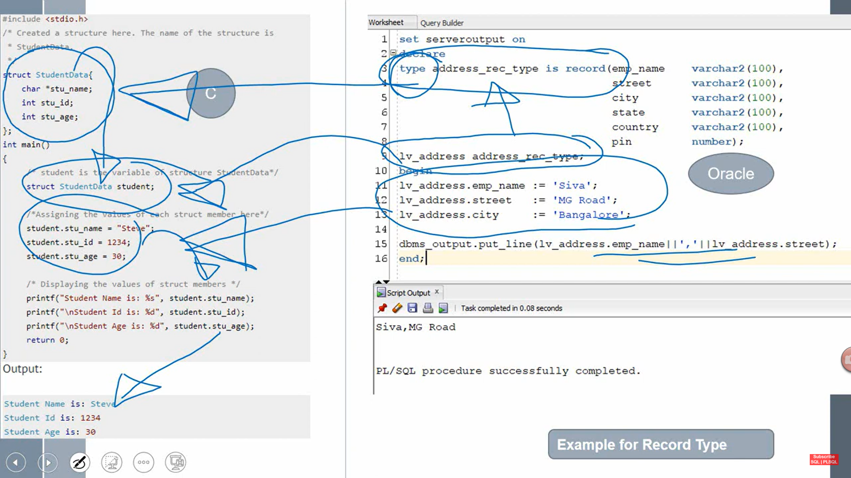

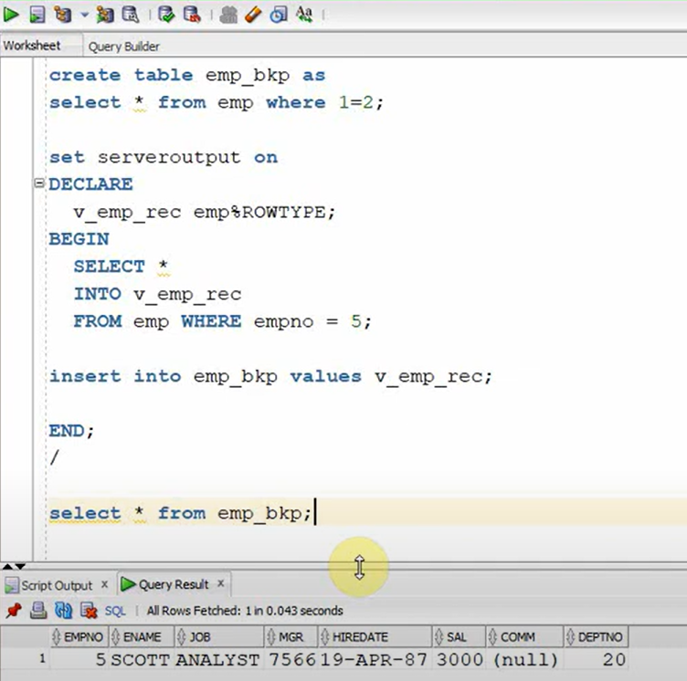

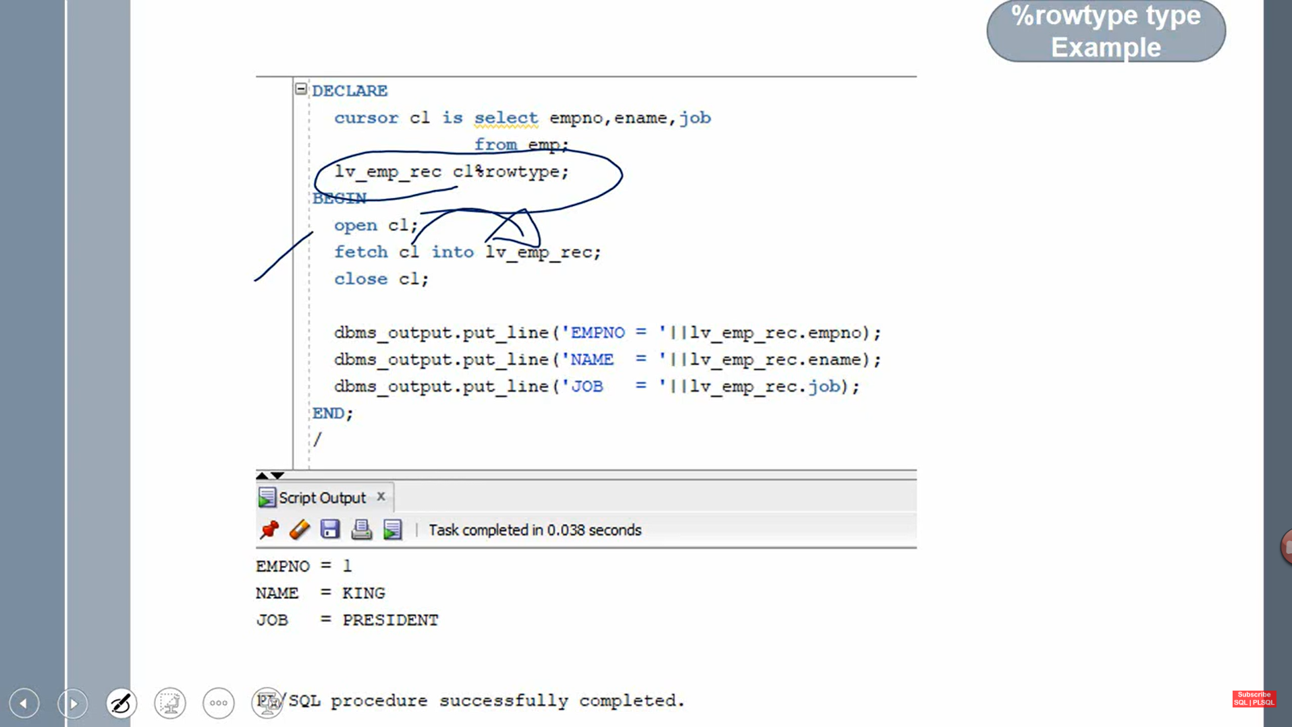

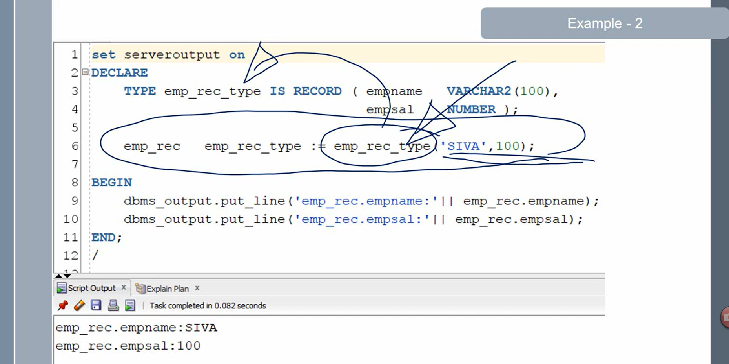

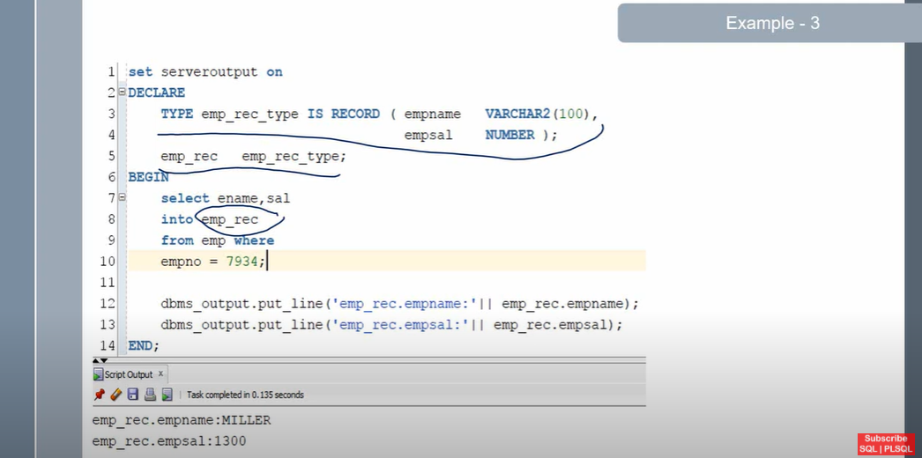

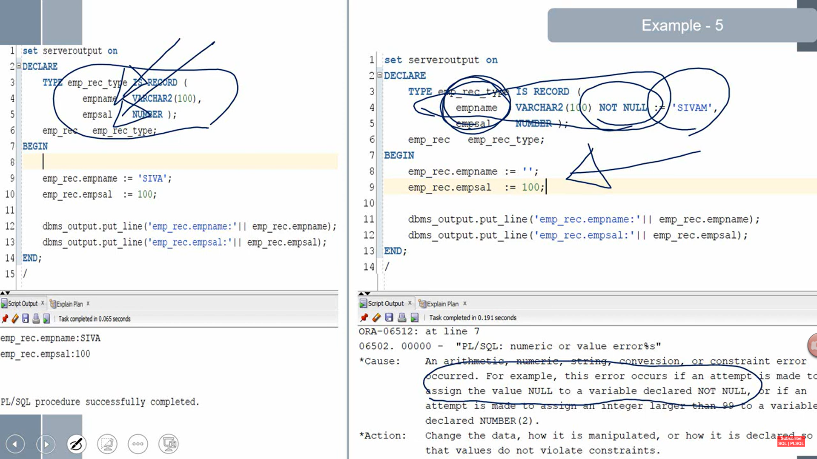

**VARRAY**

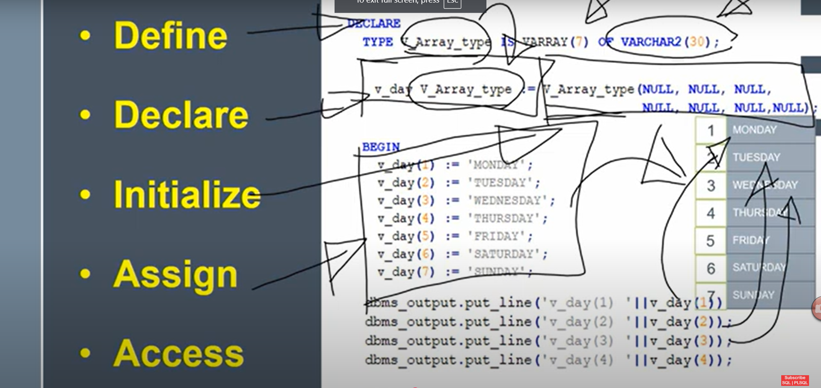

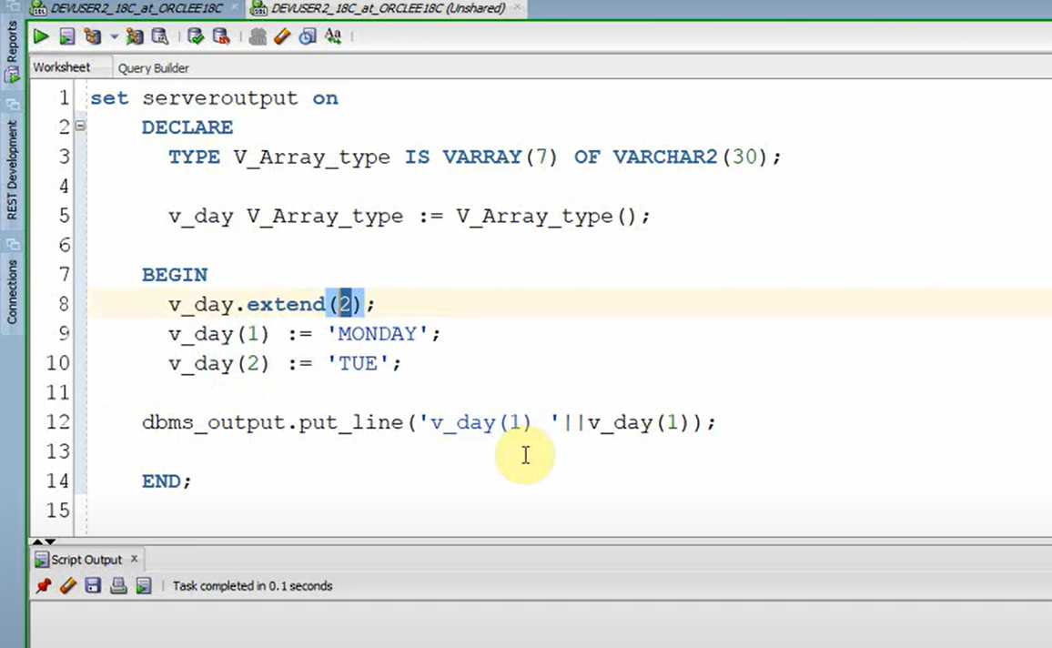

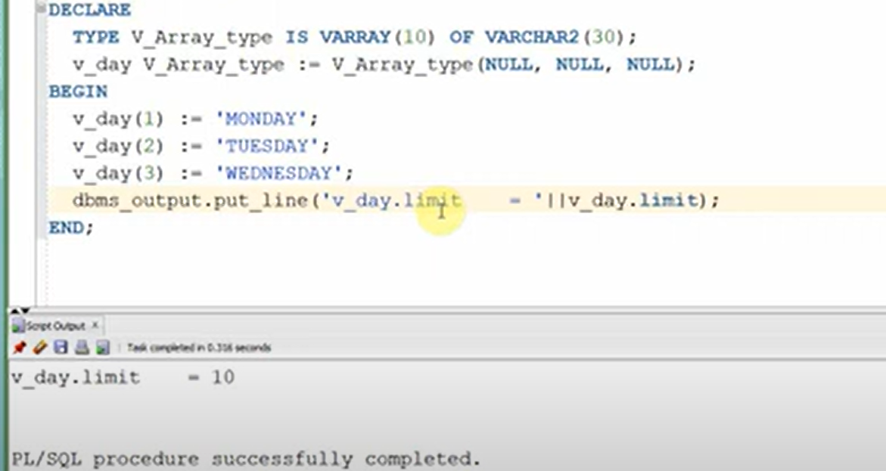

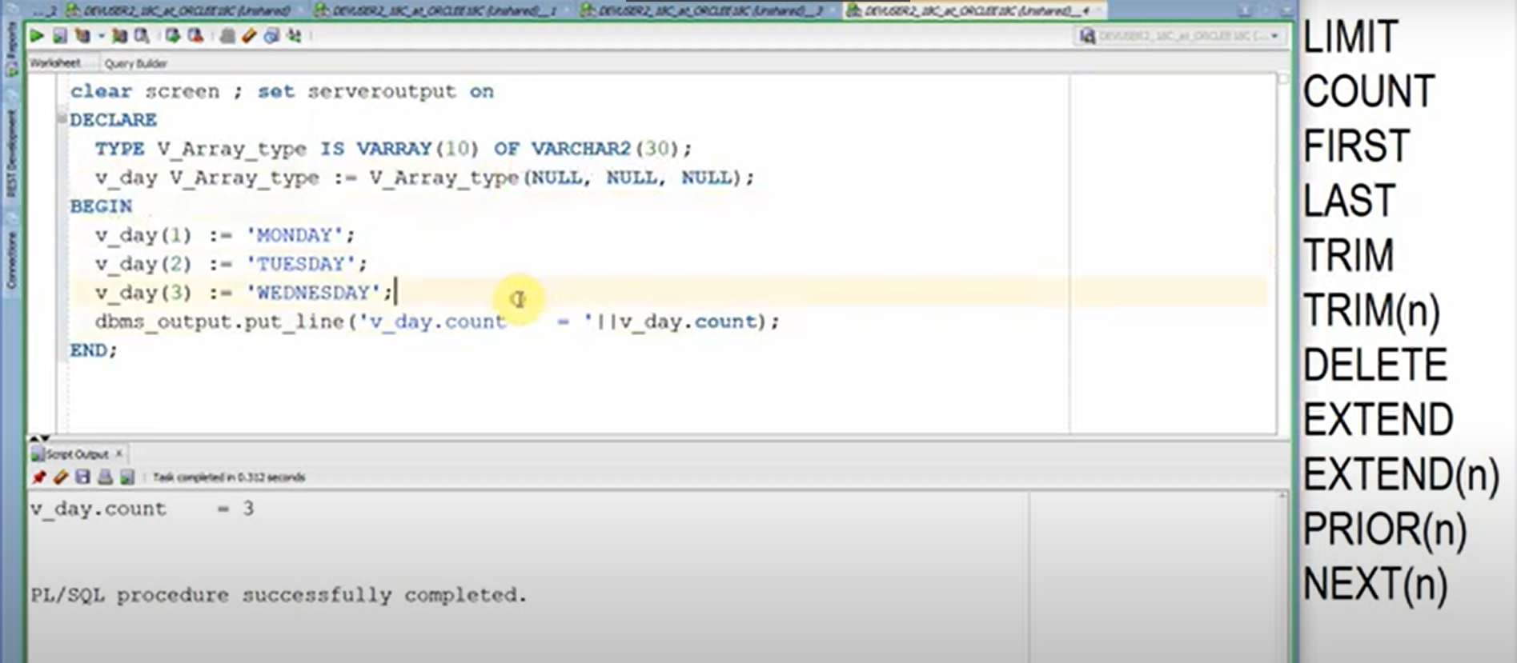

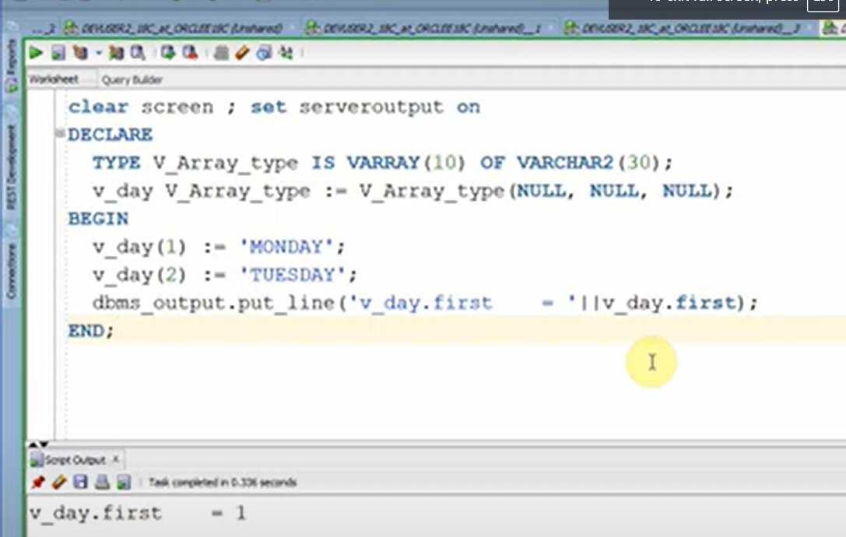

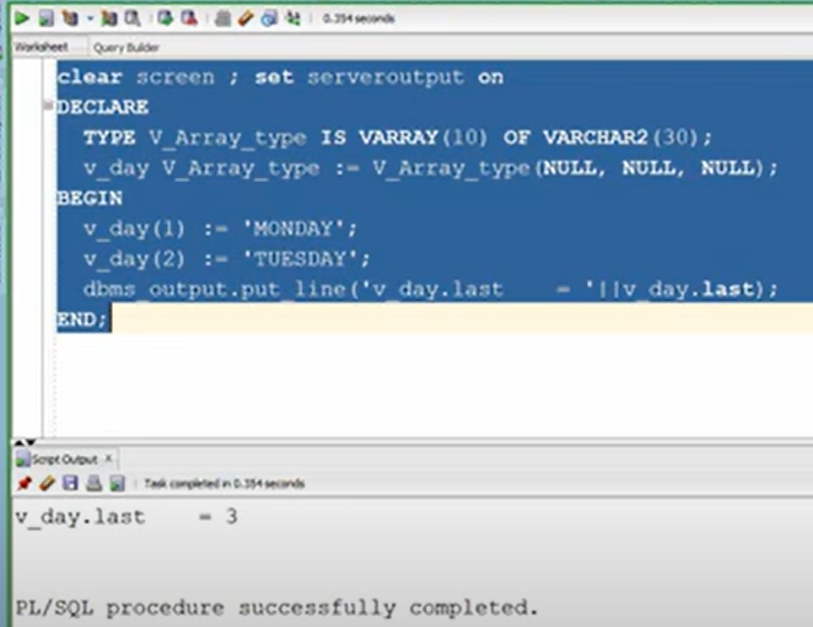

**Associative array**

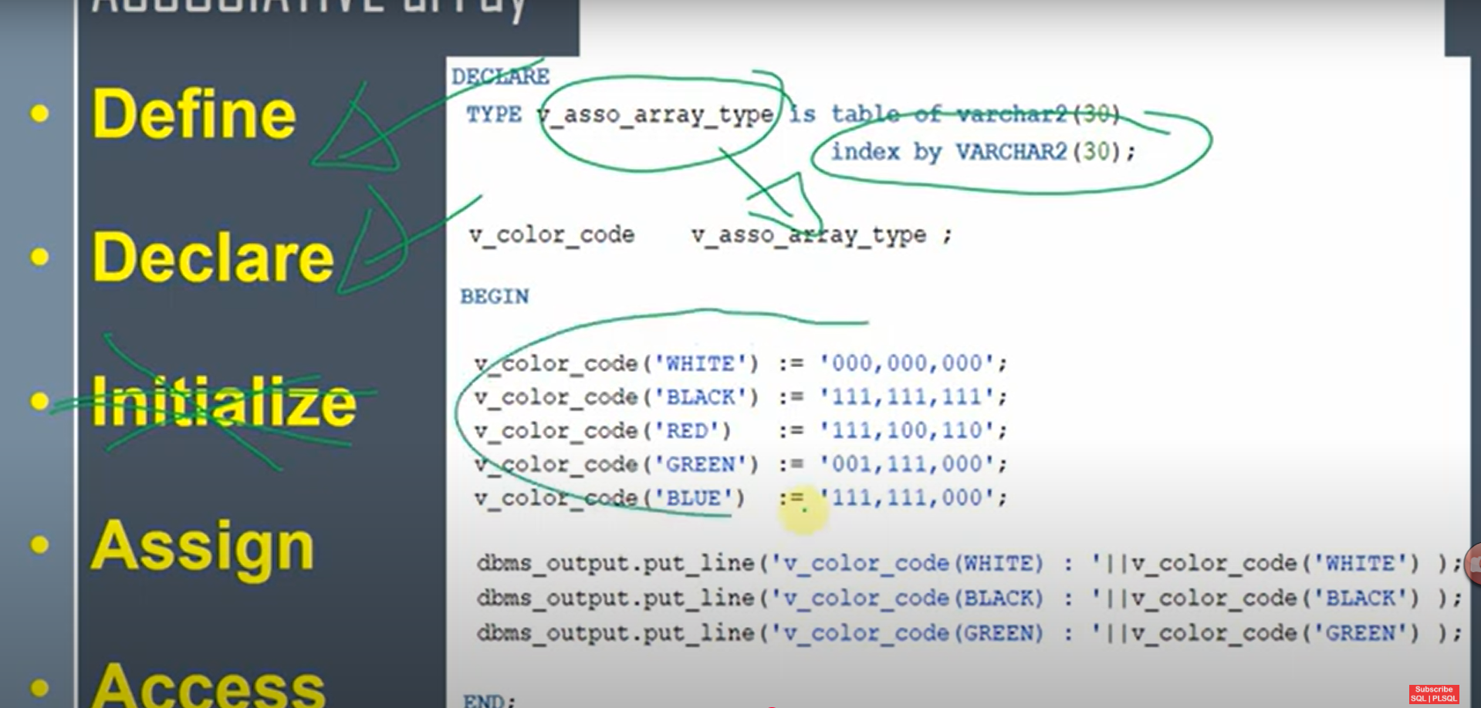

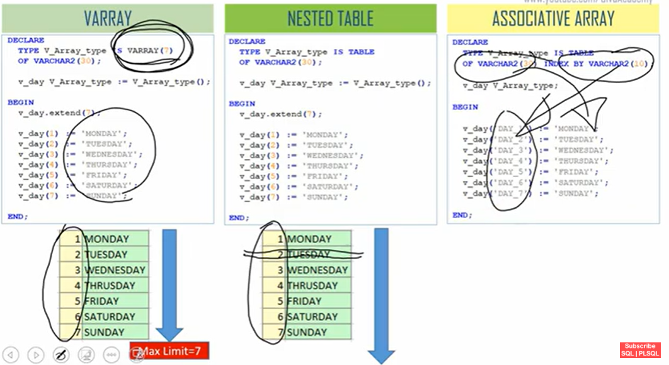

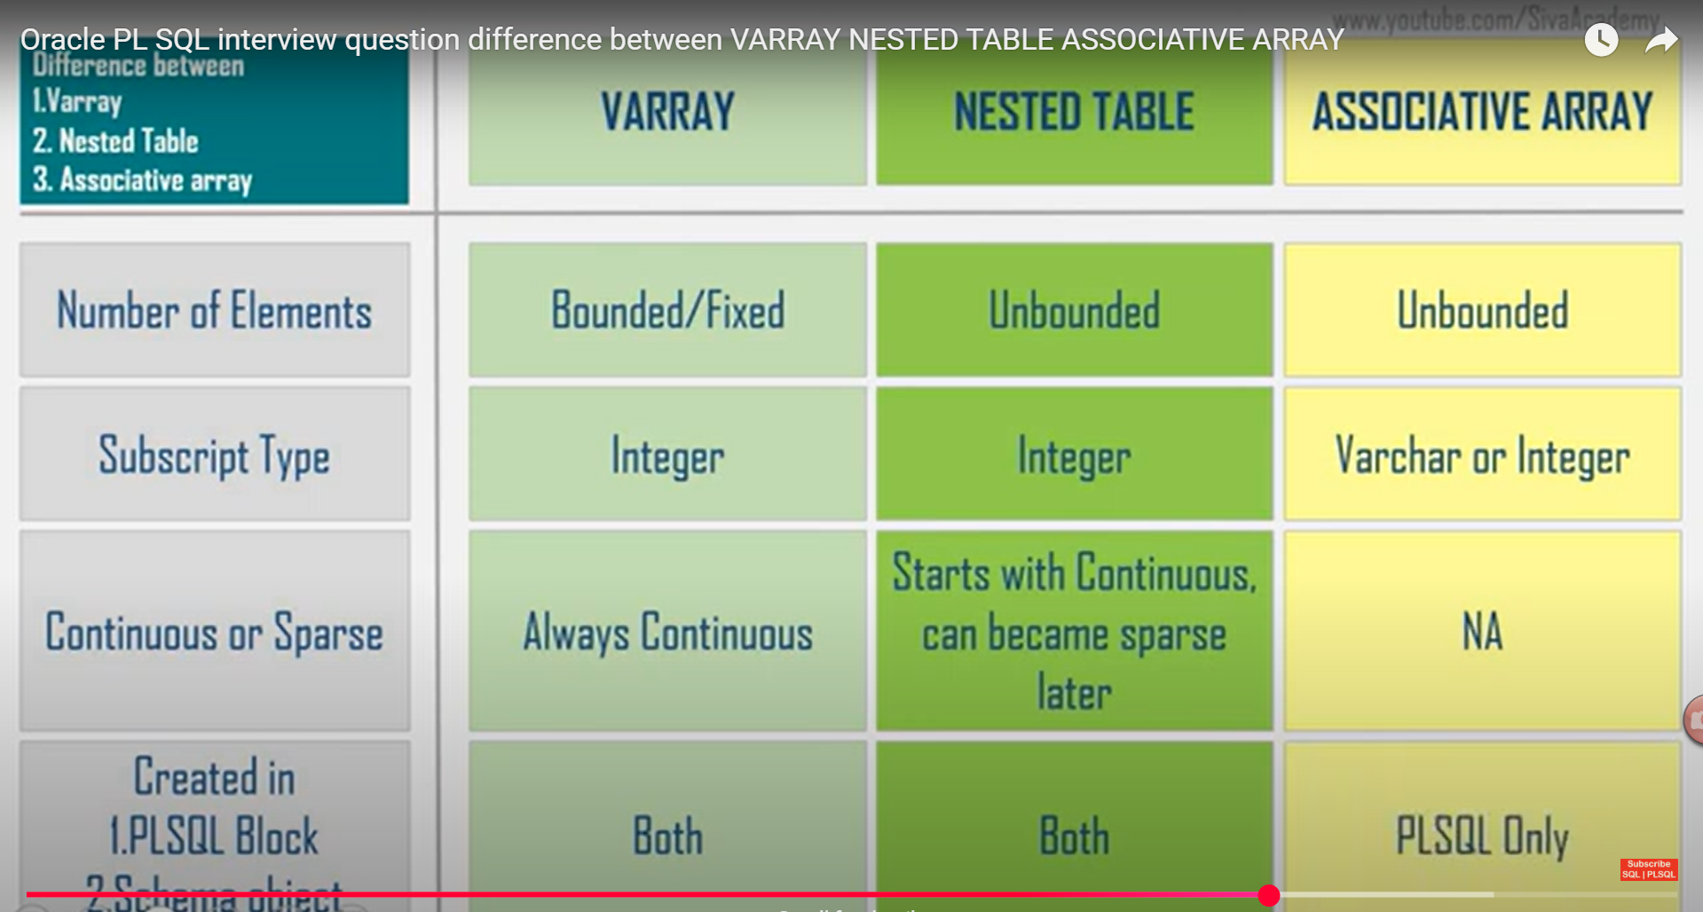

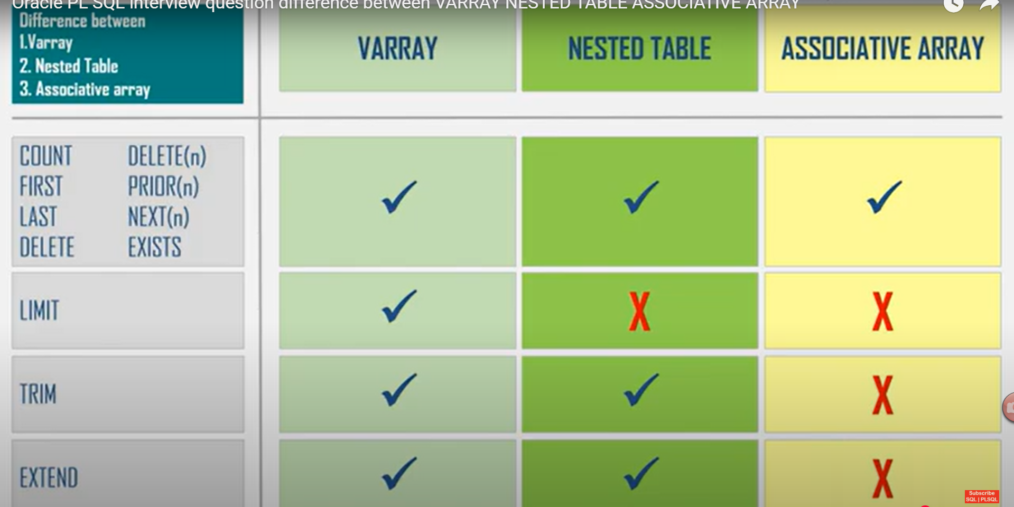

**Delete index and value of the element ----------**

Code:

**declare**

**TYPE data_collection is table of number;**

**var_nt data_collection := data_collection();**

**begin**

**var_nt.extend(4);**

**var_nt(1) := 10;**

**var_nt(2) :=11;**

**var_nt(3) := 12;**

**var_nt(4) := 13;**

**var_nt.extend(4);**

**var_nt(5) := 15;**

**var_nt(6) :=16;**

**var_nt(7) := 17;**

**-- Print all values**

**for i in 1..var_nt.count loop**

**dbms_output.put_line(i || ' ' || var_nt(i));**

**end loop;**

**-- Delete element at index 4**

**var_nt.delete(4);**

**-- Safer iteration after deletion**

**declare**

**idx PLS_INTEGER := var_nt.FIRST;**

**begin**

**while idx IS NOT NULL loop**

**dbms_output.put_line(idx || ' ' || var_nt(idx));**

**idx := var_nt.NEXT(idx);**

**end loop;**

**end;**

**exception**

**when others then**

**dbms_output.put_line('no data found');**

**end;**

**--------------------------------------------------------------------------------------------------**